Biometric Database Registration Authority

automated biometric identification systems for Israel
(ABISfI)

Request For Information Number 20/2019

Table of Contents

0 GENERAL 4
1 INTRODUCTION 5
1.1 Background 5
1.2 Classification 6
1.3 Submission date 6
1.4 Contact 6
1.5 Questions & Clarifications 6
1.6 Evaluation Process 6
1.7 Mandatory Reuirements 7
1.8 Further Evaluation 8
1.9 Post-submission Presentations and Discussions 8
1.10 Payments & Expenses 9
1.11 Presentations, Demo & Loan of the system 9
2 SYSTEM HIGH LEVEL DESCRIPTION 11
2.1 General 11
2.2 Background 11
2.3 System Concept 13
2.4 High Level Modules & Functionalities 13
2.5 Main Inputs 15
2.6 De-duplication Main Process 17
3 Functions and Services 18
3.1 General 18
3.2 Biometric Identity Management 18
3.3 Additional functionalities 18
3.4 Data interchange with external systems 19
3.5 Architecture & Technology 19
3.6 Security 20
3.7 Privacy 20
3.8 Project Management 21
3.9 Acceptance Tests and Procedures 22
3.10 Support and maintenance 22
3.11 Standards 22
4 SUBMISSION METHOD 25
4.1 Managerial Chapter 25
4.2 Technical Chapter 25
4.3 Financial Chapter 25

GENERAL
This RFI is submitted in English and in a separate Hebrew version where only Paragraph 1 - Introduction only is in Hebrew.
All other sections containing the technical information are in English.
The overall response to this document will be in accordance with the attached appendix in English.

INTRODUCTION

Background
The Biometric Database Management Authority (BDMA) of Israel is currently operating an ABIS system provided by Gemalto (Cogent technology), and is considering to issue a new RFP to replace the current system.
BDMA is interested in receiving information about organizations that are able to deliver a system based on a proven product and support services to perform this duty.
This is part of a general review of the issue and is meant to prepare a list of potential suppliers / manufacturers for potential participation in an RFP.
Without this constituting an obligation on its part, BDMA invites organizations engaged in the aforementioned field and meeting the following requirements to submit information:
- An organization that is a legally registered corporation was engaged in the provision of integrative project management for the establishment of an ABISFI and/or provision of technical assistance and support for ABISFI to at least two customers.
- An organization such as the aforementioned which itself delivered had performed at least two integrated projects that includes an ABISFI.
Organizations such as the aforementioned that are interested in such are requested to submit any relevant information, including but not limited to:
- Information about the company, including a description of its experience in similar delivery.
- Exact specification of the technical specifications of the products, according to and in accordance with that stipulated in this document.
- List of similar projects in Israel and worldwide in which said products were delivered, with a focus on Biometric registry management, including details of contact people at the organizations for which equipment such as the aforementioned was installed.
As part of the RFI process, BDMA may request a session to present their complete operational functioning solution.
BDMA will pay a sum of 1,400 USD to a company that their responses will meet the mandatory requirements (clause 1.7) and will conduct a presentation in BDMA premises in Israel. All of this is subject to budget approval for 2020 and the establishment of the bidder in the government financial system.
However, no sum will be paid to companies by the BDMA in excess of 11,500 USD.
If more than 8 companies will submit a reply, all bidders will evenly share the maximum sum of 11,500 USD.

It is explicitly declared and emphasized that the publication of this notice is no more than the desire to receive information and does not obligate the BDMA in any matter whatsoever, including with respect to an IT system, including the manner of contractual engagement and work method.
That said, BDMA reserves the right to use the information received through this notice to compile a list of potential suppliers, as aforementioned, at its sole discretion.
It should be emphasized that should an RFP process be conducted in the future, BDMA shall be entitled to change or add conditions and requirements at its professional discretion and in accordance with its needs.
BDMA reserves the right to contact anyone who responds to this notice with a request for additional information and clarification, as needed and to extend the date for response as stipulated in the foregoing.

Classification
Not classified in this stage.

Submission date
All said information must be submitted by emailing the contact person below, no later than:
Date: 07/02/2020 No later than 17:00 Israel time.

Contact
The sole contact for clarifications, as well for submission is:
Name: Dmitry Levy
Role: Aplication Manager
Email address: magentest@moin.gov.il

Questions & Clarifications
Questions and clarifications must be submitted before:
Date: 10/01/2020 17:00

Evaluation Process
We are planning to conduct a two stages evaluation.
- The first stage will include mandatory requiremens verification and evaluation of key criteria from each submission, which will be followed by vendor presentations.
- The Authority may conduct a second stage which may involve, some of the final leading proposals, to install a demo system as a POC, in BDMA premises to prove their complete operational functioning of the solution and / or a visit to an operational client site.

The conduct of the evaluation of tenders shall be entirely at our discretion.
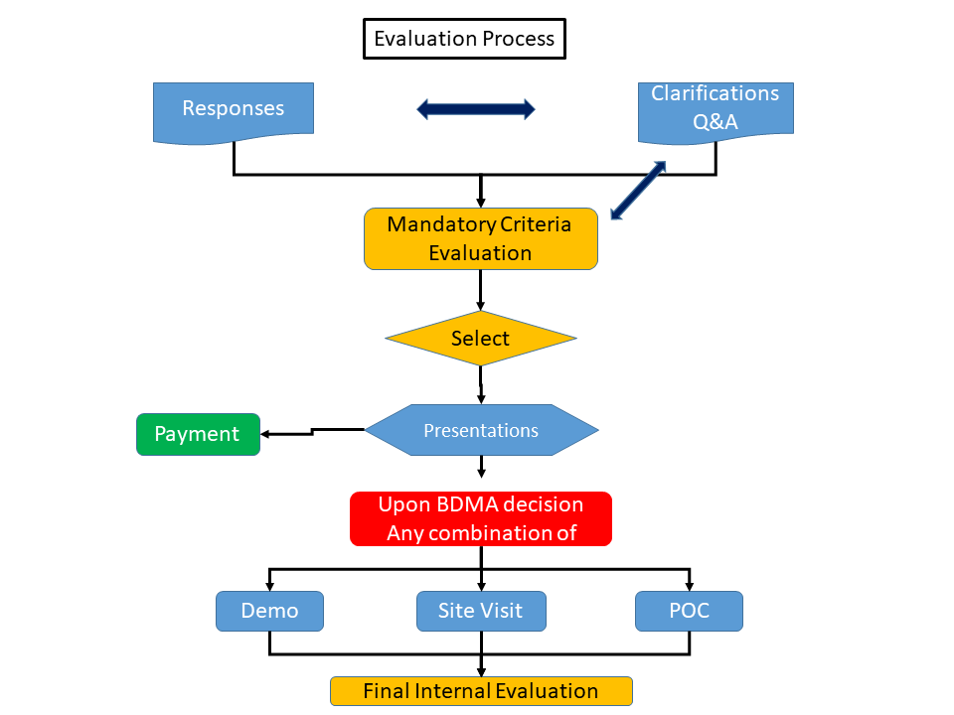

Mandatory Reuirements
The following criteria will be used for evaluation of the mandatory requirements:
- An organization that is a legally registered corporation was engaged in the provision of integrative project management for the establishment of an ABISFI to at least two customers or provision of technical assistance and support for ABISFI to at least two customers, upadated to the submission date..
- An organization such as the aforementioned which itself delivered had performed at least two integrated projects that includes an ABISFI for at lleast 10 millions identities.
- An organization such as the aforementioned which has a local support in Israel, or will have a local partner in Israel, capable of providing the technical skills of support, and security clearance to work for BDMA (a letter of intend is required).
- The implemented systems are used for Civil AFIS and not for criminal use.
- The implemented systems are used as a biometric de-duplication method to provide this service including:
- Fingerprint matching (1:N & 1:1)
- Face recognition matching (1:N & 1:1)
- Fusion matching (1:N & 1:1)
- Additional biometric technologies (future expansion)
- The service includes Authentication capabilities (1:1) and Identity resolution.
- The matching methods do not include any biographic information (reference number only) and are not doing any use of biographic in matching processes.
- Detail response to RFI
- All of the functionalities and the topics are marked as M (Mandatory) in clauses 2 and 3 below.

Further Evaluation
The Authority may conduct a second stage which may involve, some of the final leading proposals, to install a demo system as a POC, in BDMA premises to prove their complete operational functioning of the solution and / or a visit to an operational client site.
The conduct of the evaluation of tenders shall be entirely at our discretion.
The following criteria will be used for further evaluation:
- Detail response to RFI
- Presentations
- Site visit
- Demo
- POC
We will evaluate all tenders based on (but not necessarily limited to) the following guidelines:
- Your understanding of our requirements and your feedback.
- Your ability to provide the products or services in accordance with our description, including your organisational capability, management capability and competency.
- Your experience and proven track record in providing products or services of a similar size, nature and scope, including references.
- The skills, qualifications and experience of your personnel who would be involved in providing the products or services, including references.
- The approach / methodology that you use to provide the products or services.
- The content and quality of your proposal, including the degree to which the proposal completely provides the requested information in the specified format.
- The estimated costs and advantages of your proposal.
- Your ability to provide the products or services without any conflict of interest resulting from industries or clients previously or currently served by you.
- Open architecture of the solution, and ability to use standards in exposing services.
- Current client’s satisfaction from the system performance and maintenance.

Post-submission Presentations and Discussions
Following submission of proposals, we:
    - Will not enter into discussion with you about the progress of the evaluation process.
    - May ask you to meet us and to make a formal presentation on your proposal. An email will be sent to the contact person two weeks before the presentation.
    - We may ask you, to install a demo system as a POC, in BDMA premises to prove their complete operational functioning
The intention of these presentations, discussions is to resolve any issues and to refine the requirements based on the vendors' proposals and to further assess the vendors' services.

Payments & Expenses
The companies will develop the responses on their own expenses.
BDMA will pay a sum of 1,400 USD to a company that their responses will meet the mandatory requirements (clause 1.7) and will conduct a presentation in BDMA premises in Israel. All of this is subject to budget approval for 2020 and the establishment of the bidder in the government financial system.
However, no sum will be paid to companies by the BDMA in excess of 11,500 USD.
If more than 8 companies will submit a reply, all bidders will evenly share the maximum sum of 11,500 USD.

Presentations, Demo & Loan of the system
Hereinafter a short description of the content expected in:
- Presentation
- Company profile
- Former Relevant experience
- Solution presentation
- Client clarifications request
- Open discussion and Q&A
- Short demo (optional)

- Demo
- System overview and demo
- Specific system modules demo
- System workflow mechanism
- De-duplication service
- Identity resolution functionalities
- Reporting demo
- Open discussion and Q&A

- Site visit
A site visit to the bidder premises and/or to an operational system client, shall include:
- Presentation and demo – see a) and b) above
- Open session with the client
- Open discussion with a client without company representatives (30 minutes)

- POC & Loan
Upon BDMA decision to use the option that the tools proposed be installed in a test environment to prove their complete operational functioning:
The bidders will be requested to provide the system and products and quote a price for a POC and loan including installation of the proposed software, training and any activities required for their proper and complete activation for a period of 60 days.
The POC will be held in Israel at BDMA premises and will include:
- Installation of the system including all licenses required for a full operation (limited volumes), and biometric data sets (limited volumes).
- Presentation and demo – see a) and b) above
- Training BDMA team (2-3 people)
- Implementation of the following workflow processes:
- Dual control process
- Handling suspicious records
- Identity resolution
- Parameters management
- Reporting
- Client questions and clarification request
- Proposer SPOC for further clarification

SYSTEM HIGH LEVEL DESCRIPTION

General

The proposal will be submitted according to the description and information of the RFI and shall be submitted in the form structure attached according the instructions below.

Classification of Specification Items (M)
The following classification will be used for response evaluation of the requirements:
Specification items are marked according to the following categories:

I - (Information) Items for information only.
Bidders respond as follows:
“We have read, understood and accept this item.” Any reservations or comments must be noted.

S - (Specific) Items that require precise, detailed responses, using the specified format noted, such as details, completion of a table, attachment of certificates, etc.
Theseare typically closed items. Bidders may add information beyond the information requested in G-type items. In the event of an extensive amount of information, such additional information should be attached as an appropriately marked appendix.

M - (Mandatory) Pre-requisite (Go/No Go) or mandatory items. Responses to M items are:
- We have read, understood and accept this item, or
- We have read, understood, and will comply with this item, or
- A complete response (such as required for S items), or
- Approval/certification furnished as required, according to the matter and content of the item.

Background
The ABISFI has been set up to manage a biometric database in order to provide de-duplication services for the national citizen’s registry and issuance of Israel national e-ID and e-Passport (PIBA responsibility).
The ABSFI is managed by a separate authority according the Israeli law, the National Biometric Database Authority (BDMA).
The system is implementing a biometric de-duplication method to provide this service including:
- Fingerprint matching
- Face recognition matching
- Fusion matching
- Additional biometric technologies (future expansion)
In addition the service includes authentication capabilities (1:1) and Identity resolution.
The system does not include any biographic information (reference number only) and is not doing any use of biographic in matching processes.
The system is to be designed and operate according the legislation in Israel for biometric and privacy.

System Concept

The system concept below presents the conceptual & logical view of the required solution together with some current features.

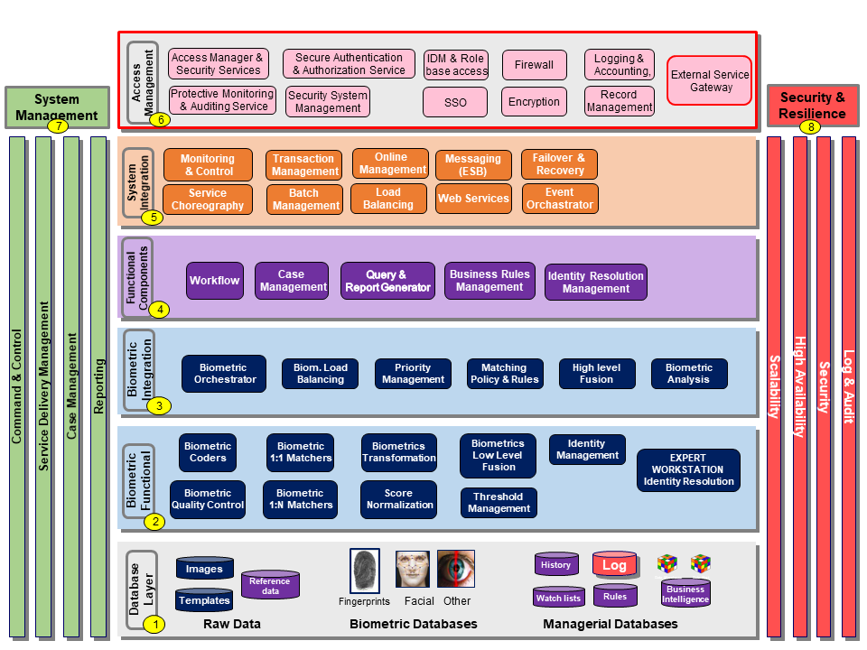

High Level Modules & Functionalities
Aligned to the diagram above.
# | Layer name | Description | class
1 | Database layer
 |  | Raw data management
 |  | Management of biometric raw data for images | M
 |  | Management of biometric raw data for templates | M
 |  | Management of biometric raw data for reference – a reference number that represent an identity. | S
 |  | Biometric database management
 |  | Management of biometric repository to enable matching for Fingerprints | M
 |  | Management of biometric repository to enable matching for Facial | M
 |  | Management of biometric repository to enable matching for additional biometric method | M
 |  | Other Managerial databases
 |  | Watch lists management (several) | M
 |  | Management of rules for policy matching and workflow processes | M
 |  | Log management | M
 |  | History management | M
 |  | Business intelligence repositories | S
2 | Biometric Functional
 |  | Use of different Biometric coders | M
 |  | Use of different Biometric Quality Control | M
 |  | Use of different Biometric 1:1 matchers | M
 |  | Use of different Biometric 1:N matchers | M
 |  | Use of different Biometrics transformation (from to) | S
 |  | Use of different Score normalization | S
 |  | Use of different Biometrics Low Level and other Fusion methods | S
 |  | Threshold Management | M
 |  | Identity Management | M
 |  | Expert Workstation for Identity Resolution, based on all biometric and information available | M
3 | Biometric Integration Layer
 |  | Use of different Biometric orchestrator for combined matching | S
 |  | Use of different Biometric Load Balancing | S
 |  | Priority Management | S
 |  | Management of matching Policy & Rules | M
 |  | Use of different Biometrics high level Fusion | S
 |  | Use of various Biometric analysis | S
4 | Functional components
 |  | Workflow tool management | M
 |  | Case management | S
 |  | Query & Report generator | M
 |  | Business rules management | M
 |  | Identity resolution management | M
5 | System Integration Layer
 |  | Monitoring & Control | S
 |  | Service Choreography | S
 |  | Transaction Management | S
 |  | Batch Management | S
 |  | Online Management | S
 |  | Load Balancing (system) | S
 |  | Messaging (ESB) | S
 |  | Web Services / Interfaces | M
 |  | Failover & Recovery | M
 |  | Event Orchestrator | S
6 | Access Management
 |  | Access manager & Security services | M
 |  | Protective monitoring & Auditing service | M
 |  | Secure authentication & Authorization service | M
 |  | Security system management | M
 |  | IDM & Role base access | M
 |  | SSO | M
 |  | Firewall | M
 |  | Encryption | M
 |  | Logging & Accounting, | M
 |  | Record Management | S
 |  | External service gateway | S
7 | System Management
 |  | Reporting | M
 |  | Case management for the whole system | S
 |  | Service delivery management | S
 |  | Command & Control | S
8 | Security & Resilience
 |  | Scalability | M
 |  | High Availability | M
 |  | Security | M
 |  | Log & Audit | M

Main Inputs
The system has two main inputs:
- Batch files which include biometric records, captured in BDMA offices, and kept in encrypted files at separate storage. These files are downloaded to CD that are manually transferred to the ABISFI through dedicated secured and decrypt process in order to start the de-duplication process.
- Verification and Authentication requests, sent by law enforcement authorities, after court confirmation, to a matching process to ABISFI. These are sent online, with expected SLA while results are sent back to authorities.
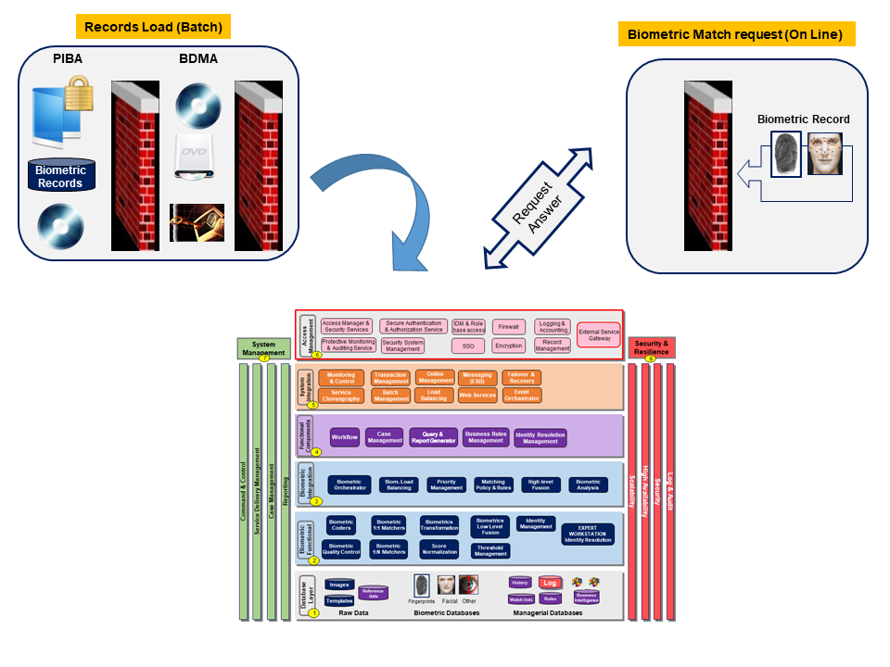

De-duplication Main Process
The main process is the de-duplication one. Some other processes are also part of the full system.
Every record is matched using several methods according pre-defined policy, including finger only, facial only, and/or Fusion.
Any record that does not meet threshold requirements definitions, is handled manually by two experts and only if both are clearing the record the operation is completed.
Otherwise it is going to further investigation process.

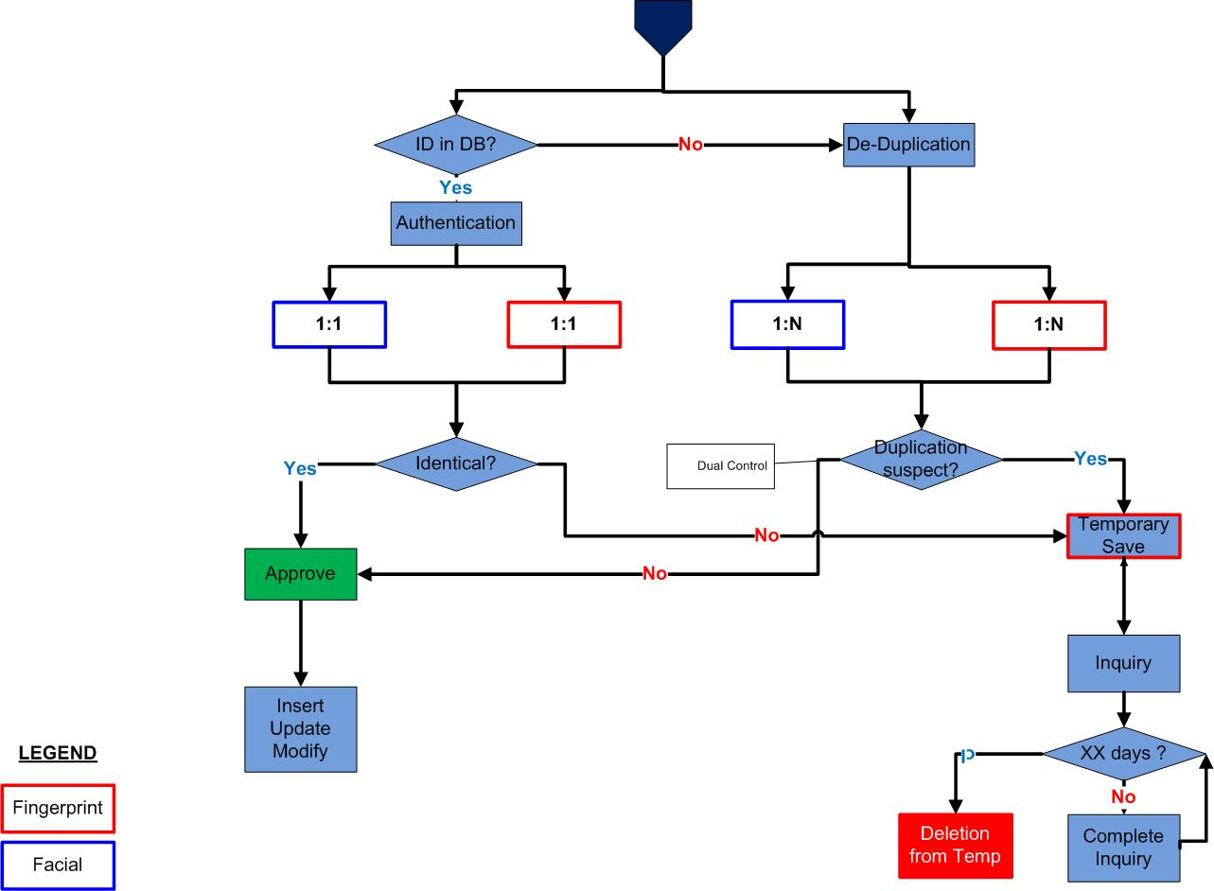

Functions and Services

General
In addition to the description above, the submitter is required to respond to the topics of this paragraph, within the tables below, and to describe its product and project.

Biometric Identity Management
# | Topic | Function description
 | Biographic capture and enrolment | Capture module for Fingerprint and Facial at least, compliant to BioApi standards and handling standard devices. | S
 | Matching performance & Accuracy | Accuracy & performance of the biometric matching for fingerprints and facial (at least). Error rates, Aging and other problems handling | M
 | Identity resolution | Capability to analyze suspicious records, in order to decide about the correct identity | M
 | Biographic data | No biographic data is handled in the current registry by Israeli law, only a "Unique Identifier” | M
 | Biometric data (Face and Fingerprints) | The system shall be able to handle various algorithms from multiple vendors and technologies | M
 | Biometric Fusion | Capability to implement various Fusion methods | M
 | Subsets matching | Capability to perform matching using data subsets on the fly (which has not been configured before) | S
 | Multi Step Search | Capability to define and perform multi step searching | S
 | Search & Queries services capabilities | Capability to query and search capability and tools | S
 | Watch list | Capability to manage and use multiple watch lists – biographic and biometrics | M
 | Fingerprint matching | Capability to perform fingerprint matching independently on finger position | M
 | Identity resolution | Functionalities of Identity resolution for Fingerprints, Facial and both | M

Additional functionalities
# | Topic | Function description
 | Workflow | Workflow engine (COTS) | S
 | Dual Control | Dual control in Identity resolution and sensitive operations. Single user cannot operate alone. Dual control to pre-defined processes | M
 | Reporting | The system will enable analysis and reporting of various types - detailed reports and graphs. Managerial and BI | S
 | MMI | An intuitive Graphical User Interface (GUI) which can be customized and applied uniformly across all workstations, supporting dual screen displays | S

Data interchange with external systems
# | Topic | Function description
 | Import | Capabilities of importing biographic records from different formats and sources. | S
 | Batch & Online interface | Batch and online procedures of interfacing the system with high security authentication, including asynchronous processes. | S
 | Export | Capability of the system exporting data to Excel for further processing and display | S
 | Web services | Enabling the various processes will be implemented through Web services and external interfaces | S

Architecture & Technology
# | Topic | Function description
 | Black Box concept | The ABISFI is to be managed as a “balck box” with external management of parameters and inputs. | S
 | System Environments | Multiple environments management (pre-Prod. To DR) | S
 | Transactional system data | Managing a transaction based system | S
 | Load Balancing | Load balancing mechanism | S
 | Backup | Backup capabilities | S
 | DRP | DR and resilience capabilities | M
 | Availability | Assuring high availability | S
 | System management | System management capabilities | S
 | Performance | Assure that the system is completing a 10,000 (and above) records per day within 12 hours, including resolution | M
 | Scalability | Moving from 5 million to 10 million and above | M
 | OS | Operating systems options | S
 | Storage | Storage management and requirements | S
 | MMI | COTS (off the shelf) product or customized tool | S
 | Language | Full Hebrew Support | M
 | Hardware | Standard hardware options | S
 | Database | Standard, off-the-shelf SQL (e.g.: MS SQL, Oracle) | M
 | Workstation | Client workstations will be standard, COTS PCs | S
 | SLA | SLA management and monitoring | S
 | Network | Capability of network connectivity to be performed in a network isolated manner using Firewalls | M

Security
# | Topic | Function description
 | IDM | Roles and Rights management including User roles, User profiles and permissions. | M
 | Software licensing | The System software licensing must not rely on hardware components (such as dongles) | M
 | No specific hardware | The System must not use built in hardware identifiers in any way, for licensing purposes (such as an HSM serial number or a MAC address). | S
 | Openess | Access to authorized personnel of the Biometric Authority, and their official representatives (with an advanced written approval) | S
 | NISA specifications | Comply with specifications of National Information Security Agency (NISA) (which will be provided to the Supplier) | M
 | Authentication | central account management for all components | S
 | Authorization | Management of authenticated users are only given  access to function(s) and data sets in relationship to their duties | M
 | PKI | use of a Public Key Infrastructure to meet the following security requirements:  1. Data encryption (data at rest);  2. Digital signature and verification;  3. Operating System and application authentication; 4. VPN Security Association (SA) authentication. | S
 | Monitoring, Audit, and Control | Capability to monitor and audit all components All login attempts to the process solution;  Password changes;  Application updates;  Application errors;  System processes activities (e.g., start/stop/errors);  Operational events defined in the process solution functional requirements. | S
 | Authentication | Two factor authentication | S

Privacy
# | Topic | Function description
 | Anonymization | Identity records are anonymized and managed by a reference number | M
 | Log & Audit | Detail log of events | M
 | Confidentiality | The process solution must be able to decrypt information received from external sources (e.g. collect solution sources). | M

Project Management
# | Topic | Function description
 | Project definition | consulting and project financing, with tailor-made business models | S
 | Deployment and operation | Solution design, installation setup and operator training | S
 | Data Migration & Conversion | Managing data migration from old system | M
 | Documentation | Documentation list and method | S
 | Detailed Specification Stage | Methodology of the phase | S
 | Customization Stage | Methodology of the phase | S
 | Training Stage | Detail training plan for all types of users | S
 | Installation | Installation phase by local team with security clearance | M
 | Delivery approach | Pre-design Phase; Design Phase;  Development and Integration Phase;  Validation and Acceptance Test Phase;  Deployment Phase; and Operational Phase. | S
 | Delivery phase timeline | Average timeline for installation to operation | S
 | Project plan | Project plan management methodology | S
 | Risk Analysis | Risk analysis methodology | S
 | Change management | Change management methodology | S
 | Requirements tracking & Management | Methodology of the processes | S
 | Place of delivery | Israel | M
 | Project Language | Hebrew for local team and English for remote team | M
 | Installation | The system shall be installed in BDMA premises by BDMA employees and own team due to security measure | M
 | Training | The scope will include training services | S
 | Biometric training | The scope shall include biometric training services | S
 | Team Experience | The experience of bidder team involved | S
 | Timetable | Provide a timetable for provision of the equipment and services | S
 | Quality assurance or risk management | Indicate how you intend to address any issues of quality assurance or risk management as part of the provision of the product or services. | S

Acceptance Tests and Procedures
# | Topic | Function description
 | Data test | Usage of standard biometric data set (such as NIST datasets) to test the system | S
 | Testing | The System must provide the necessary tools and interfaces to ensure comprehensive testing of functionality, components and devices. | S
 | Biometric testing | Use of standard biometric testing processes | S

Support and maintenance
# | Topic | Function description
 | Maitenance | Capability to maintain the system by the client team. The scope shall include Maintenance & Support services | S
 | NOC & SOC | Alert management tools | S
 | ongoing testing & Performance | Anually and during the life cycle of the system | S
 | In-service support | Hotlines, solution monitoring and auditing, system recovery and backup certification. | S
 | Local support | Local support with local security clearance | M
 | Monitor | The System must provide the necessary tools and interfaces to monitor,  Identify, refine, and rectify the relevant errors and faults in relation to capacity, performance, communication, connectivity for all components and functionality. | S
 | Defects | Rectification of Defects; Provision of any or all applicable Software updates and new releases; Replacement of Software; Provision of further enhancements; Software under updates or new releases; Provision of a telephone help desk service which is available during office hours; and On-site support, if required client | S
 | Response time | support within Response Times; Resolution Times | S
 | Parameters collection | Collection of operational parameters to measure, monitor performance and SLA | S

Standards
- The following table refers to the compliance of the proposed product to various types of standards and to add any other relevant general standard
# | Topic | Function description
 | Compliance to International standards | IT industry standards | S
 | Security | Security & Encryption standards | S
 | API | Standard API with preference will be given to services that receive and transmit information in XML (S). | S
 | Biometric Standards | All the proposed systems will meet current generally accepted global FP/PP and facial recognition standards (ANSI/NIST-ITL, and all other relevant standards). | S
 | Biometric Standards | Technical interface (Application programming interface) | S
 | Biometric Standards | Data interchange formats | S
 | Biometric Standards | Biometric profiles | S
 | Biometric Standards | Methodologies for performance testing and reporting; | S
 | Biometric Standards | Conformance testing methodologies for the base standard; and | S
 | Biometric Standards | Cross jurisdictional and society aspects of biometric technology utilization | S
- This table is focused on biometric standards, that the submitter shall refer to the following list whether and how the product is compliant and to add any other relevant biometric standard (or equivalent)
 | [ANSI_NIST] | ANSI/NIST-ITL 1-2000, American National Standard for Information Systems – Data Format for the Interchange of Fingerprint, Facial, & Scar Mark & Tattoo (SMT) Information | S
 | [CBEFF] | ISO/IEC 19785-1:2006 "Information technology - Common Biometric Exchange Formats Framework - Part 1: Data element specification" | S
 | [EBTS/F] | FBI Electronic Biometric Transmission Specification Version 8, Appendix F, September 2007. | S
 | [ISO_19784-1] | ISO/IEC 19784-1:2006 “Information technology – Biometric application programming interface – Part 1: BioAPI specification” | S
 | [ISO_19784-4] | ISO/IEC 19784-4:2011: “Information technology – Biometric application programming interface – Part 4: Biometric sensor function provider interface” | S
 | [ISO_19784-5] | Biometric Application Programming Interface — Part 2: Biometric Archive Function Provider Interface | S
 | [ISO_19785-1] | Common Biometric Exchange Formats Framework (CBEFF) — Part 1: Data Element Specification | S
 | [ISO_19785-2] | Common Biometric Exchange Formats Framework (CBEFF) — Part 2: Procedures for the Operation of the Biometric Registration Authority | S
 | [ISO_19785-3] | ISO/IEC 19785-3:2007 “Information technology – Common Biometric Exchange Formats Framework – Part 3: Patron format specification” | S
 | ISO/IEC 19794-1 | Biometric Data Interchange Format Part 1: Framework | S
 | ISO/IEC 19794-2 | Biometric Data Interchange Format — Part 2: Finger Minutiae Data | S
 | ISO/IEC 19794-3 | Biometric Data Interchange Format — Part 3: Finger Pattern Spectral Data | S
 | ISO/JEC 19794-4 | Biometric Data Interchange Format — Part 4: Finger image Data | S
 | ISO/IEC 19794-5 | Biometric Data Interchange Format Part 5: Face Image Data | S
 | ISO/IEC 19794-6 | Biometric Data Interchange Format — Part 6: Iris image Data | S
 | ISO/IEC 19794-7 | Biometric Data Interchange Format — Part 7: Signature/Sign Time Series  Data | S
 | ISO/IEC 19794-8 | Biometric Data interchange Format — Part 8: Finger Pattern Skeletal Data | S
 | ISO/JEC 19794-9 | Biometric Data Interchange Format — Part 9: Vascular Image Data | S
 | ISO/IEC 19794-10 | Biometric Data Interchange Format — Part 10: Hand Geometry Silhouette Data | S
 | ISO/IEC 19795-1 | Biometric Performance Testing and Reporting — Part 1: Principles and Framework | S
 | ISO/IEC 19795-2 | Biometric Performance Testing and Reporting — Part 2: Testing Methodologies and Scenario Evaluation | S
 | [ISO_10918-1] | ISO/IEC 10918-1:1994: “Information technology – Digital compression and coding of continuous-tone still images: Requirements and guidelines” | S
 | [ISO_15444] | “Information technology - JPEG 2000 image coding system: Core coding system” | S
 | [ISO_24709-1] | “Information technology – Conformance testing for the biometric application programming interface (BioAPI) – Part 1: Methods and procedures” | S
 | [ISO_24709-2] | “Information technology – Conformance testing for the biometric application programming interface (BioAPI) – Part 2: Test assertions for biometric service providers” | S

SUBMISSION METHOD
The proposal will be submitted according to the following outline using the “Response Template for RFI” attached to this RFI.
The proposal will be submitted in PDF and in Word format (Identical) using the template attached provided by BDMA.

Managerial Chapter
- Submitter details
- Company profile
- Executive summary
- Previous experience
- Schedule estimation for a full delivery
- Schedule estimation for installing and preparing a POC of an experimental station that includes all required licenses

Technical Chapter
- Solution overview
- Solution description and its implementation method.
- The technologies which solution details are based on.
- Detail response in the table according the specific functionalities and topics.

Financial Chapter
Price estimation structure and estimation detail will be submitted in accordance with the requirements listed below:
- Budgetary prices for licenses of the product.
- Sample cost of biometric algorithms for trials which can be attached and provided with the product (for 5 Million and 10 Million)
- Annual maintenance costs
- Price for a POC & Loan implementation, upon BDMA decision to request a POC

